**PROJECT Java Programming with Arrays 50 Points ____ *your score***

**Objective** To write a program that uses arrays to solve a business application.

***PROJECT DESCRIPTION***

Write, compile and execute a computer program which will define and initialize two hard - coded arrays ( subscripted variables ) and then populate a third array with the product of the two earlier declared arrays.

The program will simulate the business application of examining a price, quantity and amount analysis using this simple but important equation.

*Amount*  = *Price* × *Quantity*

***Information about This Project***

An example of declaring and assigning an array in the Java language is given below. Here, an integer type array is defined that holds 6 separate elements.

**int[] myArray = { 0, 1, 2, 3, 4, 5 };**

***Steps To Complete This Project***

**STEP 1**  **Open a Java Editor and Write the Program Code**

Open a suitable text editor on your computer and write the program code which will allow the user to view the product array when individual price and quantity arrays are multiplied.

Include your name, course title and date in the header comment ( remarks ) section of your program code.

Save your file as: **ArrayProcessing.java**

Use a method called **process()** that will be used to perform the element by element multiplication of the matching price and quantity variables.

Use a method called **display()** that will be used to display the program’s output as shown in the following **Figure 1** screen snapshot.

Both these methods will receive both the price and quantity arrays and either perform multiplication on the arrays or display the result of the multiplication.

Some suggested starter code for you is given in **Figure 2** sample source statements.

**STEP 2**  **Compile and Run Your Program**

Compile and run your program.

Once you have tested your program code, run your program, observe the output and compare it to the **Figure 1** screen snapshot.

**PROJECT Java Programming with Arrays**

**Figure 1 Output Screen Snapshot**

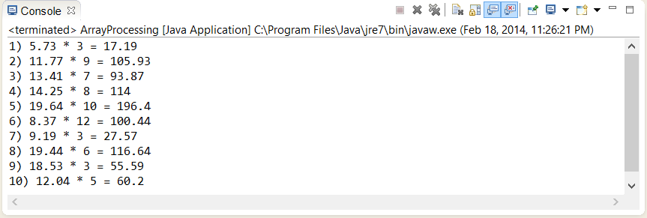

**Figure 2 Source Code for the Array Processing Application**

|  |
| --- |
| **/\*\*\*\*\*\*\*\*\*\*\*\*\*\*\*\*\*\*\*\*\*\*\*\*\*\*\*\*\*\*\*\*\*\*\*\*\*\*\*\*\*\*\*\*\*\*\*\*\*\*\*\*\*\*\*\*\*\*\*\*\*\*\*\*\*\*\*\***  **Program Name: ArrayProcessing.java**  **Programmer's Name: Sammy Student**  **Program Description: Manipulation of three arrays ********************************************************************/**  **// include any necessary packages / libraries**  **import java.text.DecimalFormat;**  **// the class file**  **public class ArrayProcessing**  **{**  **// declare the global variables for the array indices**  **public static final int index = 10;**  **public static int count = 0;**  **// declare the three arrays**  **public static double[] priceArray =**  **{ 5.73, 11.77, 13.41, 14.25, 19.64,**  **8.37, 9.19, 19.44, 18.53, 12.04 };**  **public static int[] quantityArray =**  **{ 3, 9, 7, 8, 10, 12, 3, 6, 3, 5 };**  **public static double[] amountArray =   { 0, 0, 0, 0, 0, 0, 0, 0, 0, 0 };**  **// declare a decimal formatting object**  **static DecimalFormat df = new DecimalFormat("###,###.##");** |

**PROJECT Java Programming with Arrays**

**Figure 2 Source Code for the Array Processing Application ( Continued )**

|  |
| --- |
| **// the main() method is defined**  **public static void main(String[] args)**  **{**  **// call the method named process()**  **process(priceArray, quantityArray);**    **// call the method named display()**  **display(priceArray, quantityArray);**  **}**  **// define the method named process()**  **static void process(double[] priceA, int[] quantityA)**  **{**  **// global arrays restored**  **priceArray = priceA;**  **quantityArray = quantityA;**    **// looping structure to perform the multiplication**  **for(count = 0; count < index; count++)**  **{**  **// body statement(s) for the looping structure**  **}**  **}**  **// define the method named display()**  **static void display(double[] prices, int[] quantities)**  **{**  **// global arrays restored**  **priceArray = prices;**  **quantityArray = quantities;**  **// output displayed**  **for(int i = 0; i < index; i++)**  **{**  **// body statement(s) for the looping structure**  **}**  **}**  **}//end the class** |

**STEP 3**  **Supplement Your Program Code**

Modify your working program by including, within the **display()** method a separate for loop that will display the following table, which shows the amount status as either being above or equal to $ 100.00 or being strictly below

$ 100.00 . Store the status character in a global array defined as **statusArray()** with ' A ' for ABOVE and ' B ' for BELOW.

**PROJECT Java Programming with Arrays**

**1) B**

**2) A**

**3) B**

**4) A**

**5) A**

**6) A**

**7) B**

**8) A**

**9) B**

**10) B**

**STEP 4**  **Test Your Completed Program**

Test your program code such that it displays the above table, assuming the original hard - coded values are used.

**STEP 5**  **Submit Your Program Code and Your Run Time Output(s)**

Ensure that your program has four arrays and when completed, submit your program source code as well as the program outputs showing the results of running the code.